Supplementary Material
A Population-based Recalibration Method for Updating Survival Neural Networks Models for Cardiovascular Risk Prediction in UK and China
Supplementary Methods 2
Supplementary Table 1. Measurement methods of predictors and outcome in UKB and CHERRY. 9
Supplementary Table 2. Hyperparameter search space for survival neural network models 11
Supplementary Table 3. Summary of the best-performing models. 11
Supplementary Table 4. Rescaling factors for 10-year risk prediction in the CHERRY. 12
Supplementary Table 5. Comparison of baseline characteristics between training and internal validation datasets in the UKB. 12
Supplementary Table 6. Model discrimination for men and women in the CHERRY validation sets. 13
Supplementary Table 7. Discrimination of recalibrated models in the subgroups of CHERRY external validation set. 14
Supplementary Table 8. Observed: Expected ratio of the models in UKB and CHERRY validation sets. 17
Supplementary Table 9. Net reclassification index for binary outcome by the population-based recalibrated SNNs versus the simple Cox model. 18
Supplementary Table 10. Absolute reclassification counts by the recalibrated SNNs versus simple Cox. 19
Supplementary Table 11. Net reclassification index accounted for censoring by the population-based recalibrated SNNs versus the simple Cox model. 20
Supplementary Table 12. Reclassification table accounted for censoring by the recalibrated SNNs versus simple Cox. 21
Supplementary Table 13. High-risk individual characteristics via the recalibrated Cox simple and age-specific DeepSurv in CHERRY. 22
Supplementary Table 14. High-risk individual characteristics via recalibrated Cox with age interactions and age-specific DeepSurv in CHERRY. 23
Supplementary Figure 1. Adjusted hazard ratios of traditional risk factors for incident CVD in UKB and CHERRY 24
Supplementary Figure 2. Calibration plot for 10-year risk in the UK Biobank internal validation set. 25
Supplementary Figure 3. Smoothed calibration curve by risk group in the CHERRY validation set. 26
Supplementary Figure 4. 10-year risk distribution of original and recalibrated SNN models in the CHERRY. 27
Supplementary Figure 5. Calibration plot by age group for 10-year CVD risk in the CHERRY external validation set. 28
Supplementary Figure 6. 10-year risk distribution of original Cox and SNN models in the UKB and CHERRY. 29
TRIPOD-AI Checklist 30

Supplementary Methods
1.1 Calculation steps for population-based recalibrated method.
Step 1. Estimate 10-year CVD risk (if not available).
Depending on the form of the aggregated data, there are several ways in which the rate can be transformed into risk.
- Estimated 10-year risk from probability
First, convert the T-year probability of incident CVD (P) to an annual rate (r), assuming that interested events occurred evenly throughout the study period. The T-year probability could be obtained from the national or local annual report on health statistics (e.g., the Global Burden of Disease study):
$$r=\frac{-\ln\left(1-P\right)}{T}$$
Then, convert the annual rate to 10-year CVD risk.
$$θ=1-\exp\left(-r*10\right)$$
- Estimated 10-year risk from incidence rate (unit: person-year)
If the number of individuals at the beginning of the observation period and the number of new disease cases during that time are known, the incidence rate can also be calculated per person-year (IR). Then, convert the incidence rate to 10-year CVD risk,
$$θ=1-\exp\left(-IR*10\right)$$
- Estimated 10-year risk by Kaplan-Meier estimation
If there is a stable cohort or long-term survey, the Kaplan-Meier can be used to estimate 10-year risk even without detailed individual health information, provided that event occurrences are recorded.
$$θ=1-S_{KM}\left(10\right)$$
Step 2. Calculate the rescaling factor.
First, the clog-log transforms the risk of both the derived and target populations, then calculates the difference to obtain the rescaling factor. This factor reflects, to some extent, the population-inherent disparities that may be attributed to unobserved exposures.
$$α=\ln\left[-\ln\left(1-θ_{derived}\right)\right]-\ln\left[-\ln\left(1-θ_{target}\right)\right]$$

Step 3. Calculate the recalibrated risk for each individual using the rescaling factor.
Apply the rescaling factor to adjust the original predicted risk for each individual:
$$ln\left[-ln\left(1-{risk}_{recalibrated}\right)\right]= ln\left[-\ln\left(1-{risk}_{original}\right)\right]-α$$
These steps can be performed separately by sex, provided that summarized data on disease incidence are available for both men and women.

1.2 Rescaling factor comparison: calculation in the entire vs sub-populations.
When calculating the rescaling factor, it's suggested to select a representative population for the target application scenario. For global models (e.g., the WHO risk chart) and region-specific models (e.g., SCORE2), researchers typically select populations based on their geographic location or risk level. The diversity and stability of these populations directly impact the accuracy of the rescaling factor. Given the large sample size of the CHERRY cohort and its stable follow-up, we calculated the rescaling factor using the entire cohort in the primary analysis to evaluate the predictive capacity of the recalibrated model. However, this approach may raise concerns regarding the potential for overfitting when using all information from the validation dataset, especially in smaller validation datasets.
Thus, we have conducted a sensitivity analysis to assess the stability of the incidence estimate from the full cohort. We repeatedly sampled 30% of the CHERRY cohort (100 times, without replacement), calculated the 10-year CVD incidence and corresponding rescaling factor for each sample, and examined the distribution of these factors. The results, summarized below, show narrow confidence intervals for the rescaling factors, indicating reasonable stability.
Table 1. Rescaling factor comparison.
 | Primary analysis | Sensitivity analysis
Men
10-year survival rate | 0.9190 | 0.9099(95%CI: 0.9093, 0.9105)
Rescaling factor | -0.5787 | -0.5793(95%CI: -0.5859, -0.5728)
Women
10-year survival rate | 0.9276 | 0.9274(95%CI: 0.9271, 0.9278)
Rescaling factor | -1.1126 | -1.1145(95%CI: -1.1199, -1.1091)

1.3 Individual-based recalibrated method for Cox and DeepSurv models.
The individual-level data-based recalibration method refers to the traditional Cox regression recalibration approach, which is only applicable to survival neural networks based on the Cox structure (e.g., DeepSurv). Assuming the output of the neural network for the DeepSurv model is $ϕ\left(x\right)$, the original model calculates the risk as:
$${risk}_{original}=1-S_{0}{\left(t\right)}^{^}exp\left(ϕ\left(x\right)\right)$$
Typically, the Breslow Estimator is used to calculate the baseline hazard. This method requires knowledge of the event status and timing in the target population to determine the risk sets at different time points, as well as individual-level covariates. The calculation is as follows:
$$H_{0}\left(t\right)=\sum_{i:t_{i}≤t}^{n}{\frac{d_{i}}{\sum_{j∈R_{i}}{exp\left(\vec{β}\vec{x_{j}}\right)}}}$$
$t_{i}≤t$: Indicates all time points where the event occurrence time is less than or equal to t.
$d_{i}$: The number of events (e.g., deaths or disease occurrences) at the time $t_{i}$.
$R_{i}$: The risk set at the time $t_{i}$ (i.e., the set of individuals who have not yet experienced the event and are still under follow-up).
$exp\left(\vec{β}\vec{x_{j}}\right)$: The value obtained from the exponential transformation of the linear combination of individual $j$’s covariates $x_{j}$, representing the individual's risk weight.
After calculating the baseline hazard, it can be converted to the baseline survival function, $S_{0_new}\left(t\right)$, in Cox regression or Cox-based survival neural networks. By replacing the corresponding part of the original model, the recalibrated model is obtained.
$$S_{0_new}\left(t\right)=exp\left(-H_{0}\left(t\right)\right)$$
$${risk}_{recalibrated}=1-S_{0_new}{\left(t\right)}^{^}exp\left(ϕ\left(x\right)\right)$$

1.4 Applicability of population-based recalibrated method for simulated miscalibration scenarios.
We simulated three miscalibration scenarios (see Figure 1). When the direction of risk miscalibration is consistent across different risk groups (as in scenarios 1 and 2), the observed and predicted risks show linear or near-linear relationships after the clog-log transformation. In such cases, fitting a linear regression to adjust the intercept (for scenario 1) or the slope and intercept (for scenario 2) can correct the miscalibration. Our proposed method, which adjusts the intercept on the clog-log scale based on population-level incidence, is most effective when the miscalibration is relatively consistent across risk strata (scenarios 1 and 2), reflecting a shift in the overall baseline risk between the development and validation populations.
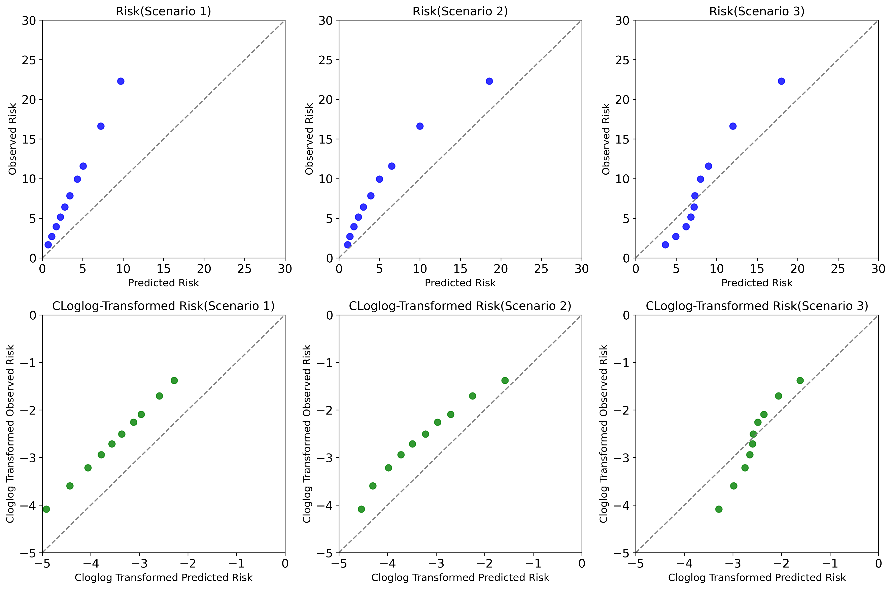
Figure 1. Different scenarios for miscalibration
Our proposed method adjusts the intercept when only overall population summary information is available. A key advantage of our approach is its flexibility depending on the granularity of the available data from the target population. If subgroup-specific incidence rates (e.g., by age) are available, we can calculate separate rescaling factors for each subgroup. This becomes equivalent to fitting a regression model where the intercept is adjusted and the slope is modified by having interaction terms between the baseline risk and the subgroup variable (shown in Figure 2 below).
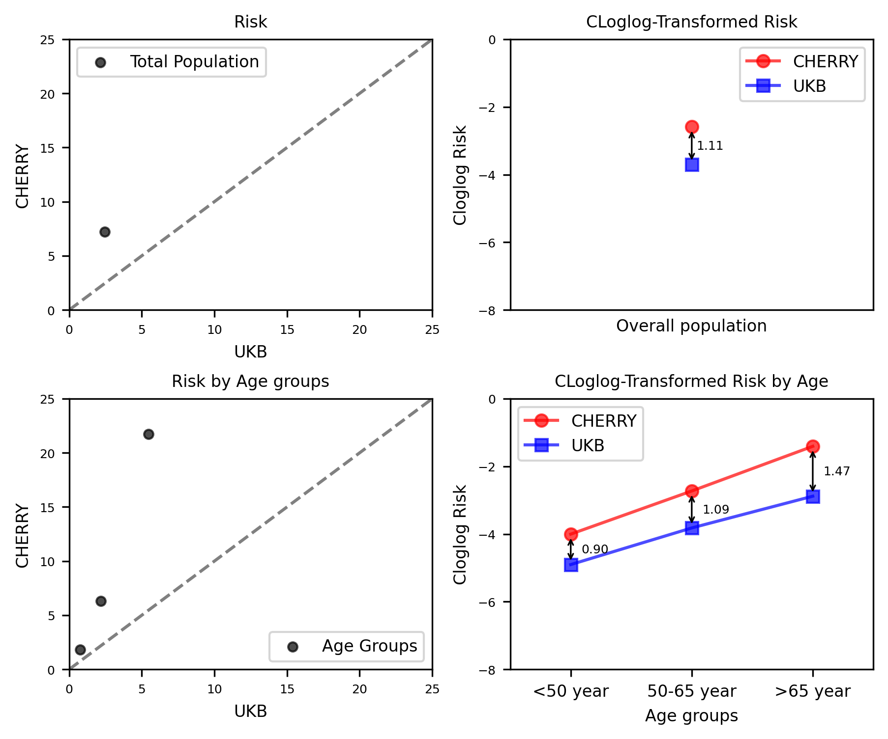
Figure 2. The proposed recalibration methods with different granularity of summarized data.

However, when the miscalibration pattern is highly inconsistent across risk groups, particularly when the direction of miscalibration reverses (e.g., scenario 3, overestimation at low risk and underestimation at high risk), a simple recalibration of the intercept (or even subgroup-specific intercepts) may not be sufficient to achieve adequate calibration, especially if the model's discrimination is also poor. In such cases, more fundamental issues with the model's specification or the underlying differences between the populations might need to be addressed, potentially requiring re-estimation of predictor effects.

1.5 Minimum sample size calculation for external validation.
We referred to the method proposed by Riley et al. [Stat Med. 2022 Mar 30;41(7):1280 - 1295.] to calculate the minimum sample size for external validation of a model with a time-to-event outcome, following the specific process below. As Riley et al. have pointed out the calibration slope is usually the measure that requires the largest sample size to estimate precisely among all predictive evaluated metrics, such as the calibration-in-the-large, the C-index, and net benefit. Due to the similar model performance of SNNs and Cox models in the UKB interval validation dataset, we calculated the sample size for the traditional DeepSurv model.
Table 2. Metrics for sample size calculation
Metrics for calculation | Values
Specify the time point of interest for checking calibration performance. | 10-year
Specify the model's anticipated linear predictor (LP) (distribution in the validation population). | Using reported Harrell’s C-index of the DeepSurv model (0.7332) in the UKB training set to compute the distribution of linear prediction: assuming follows a normal distribution with a mean of 0, a standard deviation of 0.8853.
Specify the assumed F(t) (or S(t)) in the validation population at the time point of interest. | For UKB:  F(10) = 0.0366, S(10)=0.9634  For CHERRY:  F(10) = 0.0803, S(10)=0.9197
Specify the assumed distribution of survival times in the validation population, conditional on the effect of LP. | Assuming the original model is well calibrated, and the log hazard ratio for the effect is 1 (i.e., calibration slope is 1), the survival time distribution is identified as an exponential distribution with a baseline rate parameter of approximately 0.002563 and 0.005878, which ensures F(10) is 0.0366 and 0.0803, respectively.
Specify the assumed distribution of censoring times in the validation population and maximum follow-up time. | It’s reported that the censoring rate was about 3.1% and 81.3% for the UKB and CHERRY cohort during the 10-year follow-up. Assuming a constant rate of censoring and the distribution of censoring times is identified as an exponential distribution with rate parameters of 0.0033 and 0.166, which gives the probability of being censored by 10-years of about 0.03 and 0.81, respectively.
Specify the target value for the standard error (SE) of the calibration slope. | Initially chose a SE of 0.051, to target a confidence interval width of 0.2 (i.e., 0.9-1.1 assuming the slope is 1) for the calibration slope as measured on the complementary log-log scale of the calibration model.
Calculated sample size. | For the CHERRY validation set (with an event rate of 8.03% and a censoring probability of 81% for 10-year events), approximately 29,000 individuals (with about 1,154 observed events within 10 years) are required to estimate the calibration slope with a target SE of 0.051. This sample size also satisfies the requirements for the validation population, which is similar to the UKB population (with an event rate of 3.66% and a censoring probability of 3% for 10-year events).

Supplementary Table 1. Measurement methods of predictors and outcome in UKB and CHERRY.
Items | Measurement methods in UKB | Measurement methods in CHERRY
Predictors
Age (years, continuous) | They were measured based on the baseline touchscreen questionnaire and verbal interview. | They were from general practitioner (GP)'s survey and were recorded in the Population Census and Registered Health Insurance Database.
Sex (categorical) | They were measured based on the baseline touchscreen questionnaire and verbal interview. | They were from GP's survey and were recorded in the Population Census and Registered Health Insurance Database.
Blood pressure (mmHg, continuous) | They were measured using the digital blood pressure monitor at recruitment. | They were measured by GPs or clinicians and mainly recorded in the Health Check Database, Disease Surveillance and Management Database, and Health Check Database.
Serum lipids (mmol/L, continuous) | They were measured using the blood sample collected at recruitment and repeat assessment. | They were measured by GPs or clinicians and mainly recorded in the Health Check Database, Disease Surveillance and Management Database, EMRs, and Health Check Database.
Smoking status (categorical) | They were measured based on the baseline touchscreen questionnaire and verbal interview on smoking habits, which have been summarized as the data field 20116. Valid answers could be divided into three categories (never, previous, and current smokers). | They were self-reported and mainly recorded in the Health Check Database, Population Census, Registered Health Insurance Database, Disease Surveillance and Management Database. These could be divided into three categories (never, previous, and current smokers).
History of disease (categorical) | They were measured based on the baseline touchscreen questionnaire and verbal interview. | They were diagnosed by the clinicians or reported by the GPs. They were mainly recorded in the Population Census and Registered Health Insurance Database, Death Certificates, Disease Surveillance and Management Database, and EMRs.
CVD Diagnosis
 | Information on health outcomes was from a variety of different data sources, mainly including Death registrations, hospital admissions data, and primary care data, which were summarized into the Health-related outcomes category (category ID: 100091) and UKB outcome adjudication group have also developed the algorithmically-defined outcomes (category ID:42). | They were diagnosed by the clinicians or reported by the GPs. Following the previously published protocol, event ascertainment was based on clinical symptoms, imaging data, laboratory tests, or autopsy studies. (Table S2 BMJ Open 2018; 8: e019698) They were mainly recorded in Death Certificates, Disease Surveillance and Management Databases, and EMRs.
The related information was summarized from the UK Biobank website or showcase user guide, the CHERRY protocol (BMJ Open 2018; 8: e019698), and previous studies based on the CHERRY cohort (Eur J Prev Cardiol. 2023;30(12):1293-1303; Eur Heart J Digit Health. 2023;5(1):30-40). EMRs, Electronic Medical Records.

Supplementary Table 2. Hyperparameter search space for survival neural network models
Hyper-parameters | Search space for DeepSurv | Search space for  DeepHit
Number of hidden layers | 1, 2 | 3, 4
Nodes of hidden layers | 3, 5, 7 | 7, 14, 21, 28
Dropout | 0.1, 0.3, 0.5 | 0.1, 0.3, 0.5
Learning rate (log-distribution) | [1e-4, 1e-2] | [1e-4, 1e-2]
Optimizer | Adam, SGD | Adam, SGD
Weight decay (log-distribution) | [1e-4, 1e-2] | [1e-4, 1e-2]
Momentum (uniform-distribution) | [0-1] | [0-1]

Supplementary Table 3. Summary of the best-performing models.
Hyper-parameter | Traditional DeepSurv | Age-specific DeepSurv | DeepHit
Hidden layers | [7, 3] | [9, 5] for age<50,  [9, 9] for 50≤age<65,  [7] for age≥65 | [14, 14, 7]
Batch size | 2048 | 1024 | 1024
Dropout | 0.1 | 0.1 | 0.5
Learning rate | 0.00222 | 0.00300 | 0.00036
Batch normalization | Yes | Yes | Yes
Activation for hidden layers | ReLU | ReLU | ReLU
Optimizer | Adam | Adam | Adam
Weight decay | 0.00035 | 0.00050 | 0.00296
Node of the output layer | 1 | 1 | 1*discrete time period ([0.001, 12, 24, 36, 48, 60, 72, 84, 96, 108, 114, 120, 126, 132, 144, 156, 178]), (unit:month)

Supplementary Table 4. Rescaling factors for 10-year risk prediction in the CHERRY.
 | Men | Women
Overall | -0.5787 | -1.1126
Age group
<50 years | -0.2753 | -0.8998
50-65 years | -0.4742 | -1.0921
≥65 years | -0.9368 | -1.4747

Supplementary Table 5. Comparison of baseline characteristics between training and internal validation datasets in the UKB.
 | Training dataset | Internal validation dataset | P value
Number of participants, n (%) | 277,765(80) | 69,441(20) | -
Sex: men, n (%) | 151949(54.7) | 38100(54.9) | 0.4414
Age at baseline | 58.0(50.0-63.0) | 58.0(50.0-63.0) | 0.5693
Systolic blood pressure, mmHg | 136.0(124.5,149.5) | 136.0(124.5,149.5) | 0.5840
Total cholesterol, mmol/L | 5.7(5.0,6.5) | 5.7(5.0,6.5) | 0.8966
High-density lipoprotein cholesterol, mmol/L | 1.4(1.2,1.7) | 1.4(1.2,1.7) | 0.1448
Smoking status, n (%) |  |  | 0.1794
Non-smoker | 155,046(55.8) | 39,006(56.2)
Ever/Current smoker | 122719(44.2) | 30435(43.8)
History of diabetes, n (%) | 11691(4.2) | 3018(4.3) | 0.1084
Follow-up, months | 148 (138-156) | 148 (138-156) | -
Number of CVD cases, n (%) | 13,643(4.91) | 3461(4.98) | -
Incidence of CVD, n/10,000 person-year (95% CI) | 41.02(40.34-41.72) | 41.68(40.31-43.09) | -
10-year Kaplan-Meier CVD rate, % (95%CI) | 3.71(3.63-3.78) | 3.85(3.71-4.01) | -
Data are n (%), or median (25th-75th percentile). CHERRY, CHinese Electronic health Records Research in Yinzhou; CVD, cardiovascular diseases; CI, confidence interval.

Supplementary Table 6. Model discrimination for men and women in the CHERRY validation sets.
 | Men |  |  | Women
 | Harrell’s C index  (95% CI) | Difference of C index vs. Simple Cox model | P value | Harrell’s C index  (95% CI) | Difference of C index vs. Simple Cox model | P value
Original models
Simple Cox | 0.7036(0.6964,0.7108) | - | - | 0.7591(0.7522,0.7661) | - | -
Cox with age interactions | 0.7104(0.7032,0.7176) | 0.0068(0.0056,0.0081) | <0.001 | 0.7590(0.7519,0.7660) | -0.0002(-0.0014,0.0011) | 0.7980
Traditional DeepSurv | 0.7128(0.7055,0.7200) | 0.0092(0.0073,0.0111) | <0.001 | 0.7603(0.7533,0.7673) | 0.0011(-0.0001,0.0024) | 0.0730
Age-specific DeepSurv | 0.7165(0.7093,0.7237) | 0.0129(0.0107,0.0151) | <0.001 | 0.7587(0.7517,0.7657) | -0.0005(-0.0020,0.0011) | 0.5540
DeepHit | 0.7039(0.6966,0.7111) | 0.0003(-0.0004,0.0010) | 0.4510 | 0.7578(0.7508,0.7648) | -0.0013(-0.0022,-0.0005) | 0.0020
Individual-based recalibrated models
Simple Cox | 0.7036(0.6964,0.7108) | - | - | 0.7592(0.7522,0.7661) | - | -
Cox with age interactions | 0.7104(0.7032,0.7176) | 0.0068(0.0056,0.0081) | <0.001 | 0.7590(0.7519,0.7660) | -0.0002(-0.0014,0.0011) | 0.798
Traditional DeepSurv | 0.7128(0.7055,0.7200) | 0.0092(0.0073,0.0111) | <0.001 | 0.7603(0.7533,0.7673) | 0.0011(-0.0001,0.0024) | 0.073
Age-specific DeepSurv | 0.7190(0.7119,0.7262) | 0.0155(0.0131,0.0178) | <0.001 | 0.7603(0.7534,0.7673) | 0.0012(-0.0001,0.0025) | 0.078
Population-based recalibrated models
Simple Cox | 0.7036(0.6964,0.7108) | - | - | 0.7591(0.7522,0.7661) | - | -
Cox with age interactions | 0.7104(0.7032,0.7176) | 0.0068(0.0056,0.0081) | <0.001 | 0.7590(0.7519,0.7660) | -0.0002(-0.0014,0.0011) | 0.798
Traditional DeepSurv | 0.7128(0.7055,0.7200) | 0.0092(0.0073,0.0111) | <0.001 | 0.7603(0.7533,0.7673) | 0.0011(-0.0001,0.0024) | 0.073
Age-specific DeepSurv | 0.7215(0.7144,0.7287) | 0.0180(0.0154,0.0205) | <0.001 | 0.7602(0.7533,0.7672) | 0.0011(-0.0003,0.0025) | 0.137
DeepHit | 0.7039(0.6966,0.7111) | 0.0003(-0.0004,0.0010) | 0.451 | 0.7578(0.7508,0.7648) | -0.0013(-0.0022,-0.0005) | 0.002

Supplementary Table 7. Discrimination of recalibrated models in the subgroups of CHERRY external validation set.
 | Harrell’s C index | vs. Simple Cox model |  |  | vs. Cox model with age interactions
 | (95% CI) | difference of C index | P value |  | difference of C index | P value
Sex group
Men (n=82535, 46.43%)
Simple Cox | 0.7036(0.6964,0.7108) | - | - |  | - | -
Cox with age interactions | 0.7104(0.7032,0.7176) | 0.0068(0.0056,0.0081) | <0.001 |  | - | -
Traditional DeepSurv | 0.7128(0.7055,0.7200) | 0.0092(0.0073,0.0111) | <0.001 |  | 0.0023(0.0009,0.0038) | 0.002
Age-specific DeepSurv | 0.7215(0.7144,0.7287) | 0.0180(0.0154,0.0205) | <0.001 |  | 0.0111(0.0009,0.0132) | <0.001
DeepHit | 0.7039(0.6966,0.7111) | 0.0003(-0.0004,0.0010) | 0.451 |  | -0.0066(-0.0078,-0.0054) | <0.001
Women (n=95221,53.57%)
Simple Cox | 0.7591(0.7522,0.7661) | - | - |  | - | -
Cox with age interactions | 0.7590(0.7519,0.7660) | -0.0002(-0.0014,0.0011) | 0.798 |  | - | -
Traditional DeepSurv | 0.7603(0.7533,0.7673) | 0.0011(-0.0001,0.0024) | 0.073 |  | 0.0013(0.0002,0.0024) | 0.018
Age-specific DeepSurv | 0.7602(0.7533,0.7672) | 0.0011(-0.0003,0.0025) | 0.137 |  | 0.0012(0.0003,0.0022) | 0.014
DeepHit | 0.7578(0.7508,0.7648) | -0.0013(-0.0022,-0.0005) | 0.002 |  | -0.0012(-0.0023,-0.000) | 0.044
Age group
Age<50 years (n= 54893,30.9%)
Simple Cox | 0.6331(0.6128,0.6534) | - |  |  | - | -
Cox with age interactions | 0.6330(0.6121,0.6539) | -0.0001(-0.0076,0.0074) | 0.979 |  | - | -
Traditional DeepSurv | 0.6306(0.6098,0.6514) | -0.0025(-0.0083,0.0033) | 0.400 |  | -0.0024(-0.0084,0.0036) | 0.435
Age-specific DeepSurv | 0.6151(0.5934,0.6368) | -0.0180(-0.0357,-0.0002) | 0.047 |  | -0.0179(-0.0316,-0.0042) | 0.010
DeepHit | 0.6014(0.5789,0.6240) | -0.0317(-0.0479,-0.0155) | <0.001 |  | -0.0316(-0.0446,-0.0185) | <0.001
50≤Age<65 years (n= 95460,53.7 %)
Simple Cox | 0.6289(0.6207,0.6372) | - |  |  | - | -
Cox with age interactions | 0.6315(0.6233,0.6398) | 0.0026(0.00215,0.0037) | <0.001 |  | - | -
Traditional DeepSurv | 0.6297(0.6214,0.6380) | 0.0008(-0.0015,0.0031) | 0.507 |  | -0.0018(-0.0040,-0.0003) | 0.097
Age-specific DeepSurv | 0.6179(0.6093,0.6265) | -0.01110(-0.0114,-0.0077) | <0.001 |  | -0.0137(-0.0171,-0.0103) | <0.001
DeepHit | 0.6269(0.6186,0.6352) | -0.0020(-0.0037,0.0004) | 0.017 |  | -0.0046(-0.0062,-0.0032) | <0.001
Age≥65 years (n= 27403,15.4%)
Simple Cox | 0.5799(0.5708,0.5890) | - |  |  | - | -
Cox with age interactions | 0.5882(0.5792,0.5972) | 0.0083(0.0052,0.0114) | <0.001 |  | - | -
Traditional DeepSurv | 0.5865(0.5775,0.5956) | 0.0066(0.0031,0.0102) | <0.001 |  | -0.0017(-0.0040,-0.0006) | 0.156
Age-specific DeepSurv | 0.5855(0.5765,0.5946) | 0.0056(0.0009,0.0103) | 0.019 |  | -0.0026(-0.0056,0.0003) | 0.071
DeepHit | 0.5831(0.5742,0.5921) | 0.0032(0.0002,0.0062) | 0.037 |  | -0.0051(-0.0093,0.0009) | 0.018
History of diabetes at baseline
Yes (n=13755,7.7%)
Simple Cox | 0.6684(0.6557,0.6810) | - | - |  | - | -
Cox with age interactions | 0.6661(0.6535,0.6788) | -0.0022(-0.0054,0.0009) | 0.165 |  | - | -
Traditional DeepSurv | 0.6736(0.6610,0.6862) | 0.0053(0.0016,0.0089) | 0.005 |  | 0.0042(0.0001,0.0083) | 0.045
Age-specific DeepSurv | 0.6734(0.6608,0.6861) | 0.0051(-0.0003,0.0105) | 0.067 |  | 0.0070(0.0019,0.0121) | 0.007
DeepHit | 0.6650(0.6525,0.6775) | -0.0034(-0.0065,-0.0002) | 0.035 |  | -0.0033(-0.0074,0.0008) | 0.114
No (n=164001,92.26%)
Simple Cox | 0.7289(0.7234,0.7344) | - | - |  | - | -
Cox with age interactions | 0.7323(0.7267,0.7379) | 0.0034(0.0025,0.0043) | <0.001 |  | - | -
Traditional DeepSurv | 0.7327(0.7271.0.7383) | 0.0038(0.0026,0.0050) | <0.001 |  | 0.0004(-0.0006,0.0014) | 0.399
Age-specific DeepSurv | 0.7307(0.7250,0.7364) | 0.0018(-0.0002,0.0039) | 0.079 |  | -0.0016(-0.0034,0.0003) | 0.095
DeepHit | 0.7261(0.7205,0.7318) | -0.0028(-0.0039,-0.0016) | <0.001 |  | -0.0062(-0.0073,-0.0050) | <0.001
Smoking status at baseline
Non-smoker (n=143804,80.9%)
Simple Cox | 0.7463(0.7410,0.7516) | - | - |  | - | -
Cox with age interactions | 0.7484(0.7430,0.7537) | 0.0026(0.0011,0.0029) | <0.001 |  | - | -
Traditional DeepSurv | 0.7486(0.7433,0.7539) | 0.0023(0.0011,0.0034) | <0.001 |  | 0.0003(-0.0006,0.0012) | 0.562
Age-specific DeepSurv | 0.7410(0.7354,0.7465) | -0.0054(-0.0072,-0.0036) | <0.001 |  | -0.0074(-0.0090,-0.0058) | <0.001
DeepHit | 0.7460(0.7406,0.7514) | 0.0004(-0.0015,0.0007) | 0.516 |  | -0.0024(-0.0035,-0.0013) | <0.001
Ever/Current smoker (n=33952,19.1%)
Simple Cox | 0.7217(0.7089,0.7344) | - | - |  | - | -
Cox with age interactions | 0.7251(0.7123,0.7379) | 0.0034(0.0008,0.0060) | 0.009 |  | - | -
Traditional DeepSurv | 0.7277(0.7149,0.7404) | 0.0060(0.0028,0.0092) | <0.001 |  | 0.0026(-0.0007,0.0059) | 0.121
Age-specific DeepSurv | 0.7322(0.7196,0.7448) | 0.0106(0.0066,0.0146) | <0.001 |  | 0.0071(0.0029,0.0114) | 0.001
DeepHit | 0.7208(0.7080,0.7336) | -0.0009(-0.0023,0.0005) | 0.213 |  | -0.0043(-0.0072,-0.0014) | 0.003

Supplementary Table 8. Observed: Expected ratio of the models in UKB and CHERRY validation sets.
 | Overall | Men | Women
UKB internal validation
Simple Cox | 1.027 | 1.030 | 1.027
Cox with age interactions | 1.028 | 1.030 | 1.028
Traditional DeepSurv | 1.027 | 1.067 | 0.968
Age-specific DeepSurv | 1.028 | 1.041 | 1.010
DeepHit | 1.026 | 1.029 | 1.026
CHERRY external validation
Original models
Simple Cox | 2.463 | 1.980 | 3.367
Cox with age interactions | 2.415 | 1.961 | 3.247
Traditional DeepSurv | 2.331 | 1.919 | 3.058
Age-specific DeepSurv | 2.725 | 2.427 | 3.155
DeepHit | 2.457 | 1.938 | 3.497
Population-based recalibrated models
Simple Cox | 1.148 | 1.144 | 1.160
Cox with age interactions | 1.126 | 1.134 | 1.125
Traditional DeepSurv | 1.080 | 1.109 | 1.058
Age-specific DeepSurv | 1.115 | 1.294 | 0.977
DeepHit | 1.153 | 1.121 | 1.200
Individual-based recalibrated models
Simple Cox | 1.055 | 1.026 | 1.095
Cox with age interactions | 1.026 | 1.022 | 1.036
Traditional DeepSurv | 1.040 | 1.034 | 1.052
Age-specific DeepSurv | 1.054 | 1.014 | 1.107

Supplementary Table 9. Net reclassification index for binary outcome by the population-based recalibrated SNNs versus the simple Cox model.
 | Overall | Men | Women
Traditional DeepSurv vs. Simple Cox
NRI, % (95% CI) | 3.11(2.48,3.73) | 4.19(3.25,5.13) | 1.97(1.14,2.81)
Case | 5.92(5.36,6.48) | 7.00(6.17,7.82) | 4.79(4.03,5.55)
Non-cases | -2.81(-3.08,-2.54) | -2.80(-3.26,-2.35) | -2.82(-3.16,-2.48)
Age-specific DeepSurv vs. Simple Cox
NRI, % (95% CI) | 1.38(0.62,2.14) | 3.54(2.28,4.81) | 0.52(-0.35,1.38)
Case | 0.93(0.26,1.61) | -0.85(-1.92,0.23) | 2.81(2.03,3.59)
Non-cases | 0.44(0.09,0.80) | 4.40(3.74,5.05) | -2.29(-2.67,-1.91)
DeepHit vs. Simple Cox
NRI, % (95% CI) | 0.52(-0.04,1.08) | 1.82(0.95,2.68) | -2.32(-3.06,-1.59)
Case | 1.38(0.88,1.88) | 6.81(6.08,7.55) | -4.32(-4.99,-3.65)
Non-cases | -0.86(-1.12,-0.61) | -5.00(-5.45,-4.54) | 2.00(1.70,2.30)
The results are given based on the subjects who were not censored for 10-year duration from CHERRY validation set (n=33,250) using 10% as the cut-offs of risk groups.

Supplementary Table 10. Absolute reclassification counts by the recalibrated SNNs versus simple Cox.
 |  | Population-based recalibrated traditional DeepSurv
 |  | <10% | >=10% | Total | NRI,%(95%CI)
Population-based recalibrated simple Cox |  |  |  |  | 3.11(2.48,3.73)
Non-Cases | <10% | 17165 | 875 | 18040
 | >=10% | 211 | 5370 | 5581
 | Total | 17376 | 6245 | 23621
Cases | <10% | 3816 | 666 | 4482
 | >=10% | 96 | 5051 | 5147
 | Total | 3912 | 5717 | 9629
 |  | Population-based recalibrated age-specific DeepSurv
 |  | <10% | >=10% | Total | NRI, %(95%CI)
Population-based recalibrated simple Cox |  |  |  |  | 1.38(0.62,2.14)
Non-Cases | <10% | 17200 | 840 | 18040
 | >=10% | 945 | 4636 | 5581
 | Total | 18145 | 5476 | 23621
Cases | <10% | 3892 | 590 | 4482
 | >=10% | 500 | 4647 | 5147
 | Total | 4392 | 5237 | 9629
 |  | Population-based recalibrated DeepHit
 |  | <10% | >=10% | Total | NRI,%(95%CI)
Population-based recalibrated simple Cox |  |  |  |  | 0.52(-0.04,1.08)
Non-Cases | <10% | 17461 | 579 | 18040
 | >=10% | 375 | 5206 | 5581
 | Total | 17836 | 5785 | 23621
Cases | <10% | 4115 | 367 | 4482
 | >=10% | 234 | 4913 | 5147
 | Total | 4349 | 5280 | 9629
The results are given based on the subjects who were not censored for 10-year duration from CHERRY validation set (n=33,250) using 10% as the cut-offs of risk groups.

Supplementary Table 11. Net reclassification index accounted for censoring by the population-based recalibrated SNNs versus the simple Cox model.
 | Overall | Men | Women
Traditional DeepSurv vs. Simple Cox
NRI, % (95% CI) | 2.64(1.78, 3.49) | 3.41(2.35, 4.47) | 1.74(1.02, 2.46)
Case | 5.78(4.97, 6.59) | 7.15(6.16, 8.12) | 4.38(3.68, 5.07)
Non-cases | -3.14(-3.30, -2.99) | -3.73(-3.92, -3.55) | -2.63(-2.76, -2.51)
Age-specific DeepSurv vs. Simple Cox
NRI, % (95% CI) | 1.13(0.05, 2.20) | 2.40(0.98, 3.82) | 0.66(-0.07, 1.39)
Case | 0.38(0.62, 1.37) | -1.34(-2.66, -0.02) | 2.43(1.70, 3.15)
Non-cases | 0.75(0.54, 0.97) | 3.74(3.51, 3.97) | -1.77(-1.90, -1.64)
DeepHit vs. Simple Cox
NRI, % (95% CI) | 0.02(-0.78, 0.81) | 1.20(0.40, 2.00) | -2.20(-2.91, -1.48)
Case | 1.50(0.75, 2.24) | 6.79(6.02, 7.56) | -4.21(-4.91, -3.51)
Non-cases | -1.48(-1.65, -1.31) | -5.60(-5.77, -5.42) | 2.01(1.90, 2.12)
The results are given based on all subjects from CHERRY validation set (n=177756) using 10% as the cut-offs of risk groups.

Supplementary Table 12. Reclassification table accounted for censoring by the recalibrated SNNs versus simple Cox.
 | Population-based recalibrated traditional DeepSurv
 | All | Reclassified upwards | Reclassified downwards | NRI
Kaplan-Meier rate of CVD events | 8.03% | 13.06% | 9.74% | Overall (95%CI) | 2.64% (1.78%, 3.49%)
Expected number of event subjects | 14280 | 963 | 137 | Among event subjects | 5.78%
Expected number of non-event subjects | 163476 | 6410 | 1275 | Among non-event subjects | -3.14%
 | Population-based recalibrated age-specific DeepSurv
 | All | Reclassified upwards | Reclassified downwards | NRI
Kaplan-Meier rate of CVD events | 8.03% | 13.41% | 10.48% | Overall (95%CI) | 1.13% (0.05%, 2.20%)
Expected number of event subjects | 14280 | 810 | 756 | Among event subjects | 0.38%
Expected number of non-event subjects | 163476 | 5229 | 6463 | Among non-event subjects | 0.75%
 | Population-based recalibrated DeepHit
 | All | Reclassified upwards | Reclassified downwards | NRI
Kaplan-Meier rate of CVD events | 8.03% | 10.61% | 13.27% | Overall (95%CI) | 0.02%  (-0.78%, 0.81%)
Expected number of event subjects | 14280 | 543 | 328 | Among event subjects | 1.50%
Expected number of non-event subjects | 163476 | 4570 | 2146 | Among non-event subjects | -1.48%
The results are given based on all subjects from CHERRY validation set (n=177756) using 10% as the cut-offs of risk groups.

Supplementary Table 13. High-risk individual characteristics via the recalibrated Cox simple and age-specific DeepSurv in CHERRY.
 | High-risk identified by recalibrated Cox  (Simple Cox>=10% & Age-specific DeepSurv<10%) |  |  |  | High-risk identified by recalibrated DeepSurv  (Simple Cox<10% & Age-specific DeepSurv >=10%)
 | Overall | Women | Men |  | Overall | Women | Men
No. of participants, n(%) | 7219 | 1209 | 6010 |  | 6039 | 2938 | 3101
Predicted risk, p50(p25-p75)
Simple Cox | 0.11(0.11,0.12) | 0.11(0.10,0.11) | 0.11(0.11,0.13) |  | 0.09(0.08,0.09) | 0.09(0.08,0.09) | 0.09(0.08,0.09)
Age-specific DeepSurv | 0.09(0.08,0.09) | 0.09(0.09,0.10) | 0.09(0.08,0.09) |  | 0.14(0.12,0.17) | 0.14(0.12,0.16) | 0.15(0.12,0.18)
Age, p50(p25-p75) | 60(58,62) | 63(62,64) | 60(57,62) |  | 66(65,67) | 65(56,66) | 67(66,68)
Age group, n(%)
<50 yr | 191(2.6%) | 0(0.0%) | 191(3.2%) |  | 65(1.1%) | 61(2.18) | 4(0.1%)
50-65 yr | 6954(96.3%) | 1209(100.0%) | 5745(95.6%) |  | 1380(22.9%) | 1363(46.4%) | 17(0.5%)
≥65 yr | 74(1.0%) | 0(0.0%) | 74(1.2%) |  | 4594(76.1%) | 1514(51.5%) | 3080(99.5%)
SBP, mmHg, p50(p25-p75) | 140(130,150) | 149(140,157) | 138(130,149) |  | 130(120,140) | 130(120,140) | 128(120,137)
TC, mmol/L, p50(p25-p75) | 4.96(4.35,5.63) | 4.81(4.23,5.36) | 4.99(4.38,5.69) |  | 4.83(4.19,5.54) | 5.38(4.77,6.15) | 4.39(3.90,4.91)
HDL-C, mmol/L, p50(p25-p75) | 1.20(1.04,1.40) | 1.19(1.06,1.34) | 1.21(1.04,1.41) |  | 1.39(1.17,1.65) | 1.42(1.17,1.69) | 1.36(1.16,1.61)
Smoker, n(%)
Never | 3072(42.6%) | 1171(96.9%) | 1901(31.6%) |  | 5753(95.3%) | 2869(97.7%) | 2884(93.0%)
Ever | 122(1.7%) | 0(0.0%) | 122(2.0%) |  | 248(4.1%) | 62(2.1%) | 186(6.0%)
Current | 4025(55.8%) | 38(3.1%) | 3987(66.3%) |  | 38(0.6%) | 7(0.2%) | 31(1.0%)
Diabetes, n(%) | 1059(14.7%) | 2(0.2%) | 1057(17.6%) |  | 967(16.0%) | 951(32.4%) | 16(0.5%)

Supplementary Table 14. High-risk individual characteristics via recalibrated Cox with age interactions and age-specific DeepSurv in CHERRY.
 | High-risk identified by recalibrated Cox (Cox with age interactions >=10% & Age-specific DeepSurv<10%) |  |  |  | High-risk identified by recalibrated DeepSurv (Cox with age interactions <10% & Age-specific DeepSurv >=10%)
 | Overall | Women | Men |  | Overall | Women | Men
No. of participants, n(%) | 7129 | 868 | 6261 |  | 3601 | 2079 | 1522
Predicted risk, p50(p25-p75)
Cox with age interactions | 0.11(0.11,0.13) | 0.11(0.10,0.11) | 0.12(0.11,0.13) |  | 0.09(0.08,0.10) | 0.09(0.08,0.10) | 0.09(0.08,0.10)
Age-specific DeepSurv | 0.09(0.08,0.09) | 0.09(0.09,0.10) | 0.08(0.08,0.09) |  | 0.13(0.11,0.14) | 0.12(0.11,0.14) | 0.13(0.11,0.15)
Age, p50(p25-p75) | 60(56,62) | 64(62,64) | 59(56,62) |  | 65(60,66) | 61(57,65) | 66(65,67)
Age group, n(%)
<50 yr | 730(10.2%) | 65(7.5%) | 665(10.6%) |  | 7(0.2%) | 7(0.3%) | 0(0.0%)
50-65 yr | 6298(88.3%) | 803(92.5%) | 5495(87.8%) |  | 1266(35.2%) | 1249(60.1%) | 17(1.1%)
≥65 yr | 101(1.4%) | 0(0.0%) | 101(1.6%) |  | 2328(64.6%) | 823(39.6%) | 1505(98.9%)
SBP, mmHg, p50(p25-p75) | 140(130,150) | 150(140,160) | 139(130,150) |  | 128(120,139) | 130(120,140) | 125(119,134)
TC, mmol/L, p50(p25-p75) | 5.05(4.41,5.74) | 4.69(4.13,5.30) | 5.10(4.47,5.81) |  | 4.96(4.30,5.72) | 5.49(4.85,6.29) | 4.38(3.89,4.85)
HDL-C, mmol/L, p50(p25-p75) | 1.20(1.03,1.39) | 1.20(1.06,1.34) | 1.20(1.03,1.40) |  | 1.38(1.15,1.65) | 1.40(1.13,1.68) | 1.36(1.17,1.60)
Smoker, n(%)
Never | 3020(42.4%) | 837(96.4%) | 2183(34.9%) |  | 3459(96.1%) | 2020(97.2%) | 1439(94.5%)
Ever | 140(2.0%) | 0(0.0%) | 140(2.2%) |  | 125(3.5%) | 59(2.8%) | 66(4.3%)
Current | 3969(55.7%) | 31(3.6%) | 3938(62.9%) |  | 17(0.5%) | 0(0.0%) | 17(1.1%)
Diabetes, n(%) | 1460(20.5%) | 56(6.5%) | 1404(22.4%) |  | 733(20.4%) | 721(34.7%) | 12(0.8%)

Supplementary Figure 1. Adjusted hazard ratios of traditional risk factors for incident CVD in UKB and CHERRY
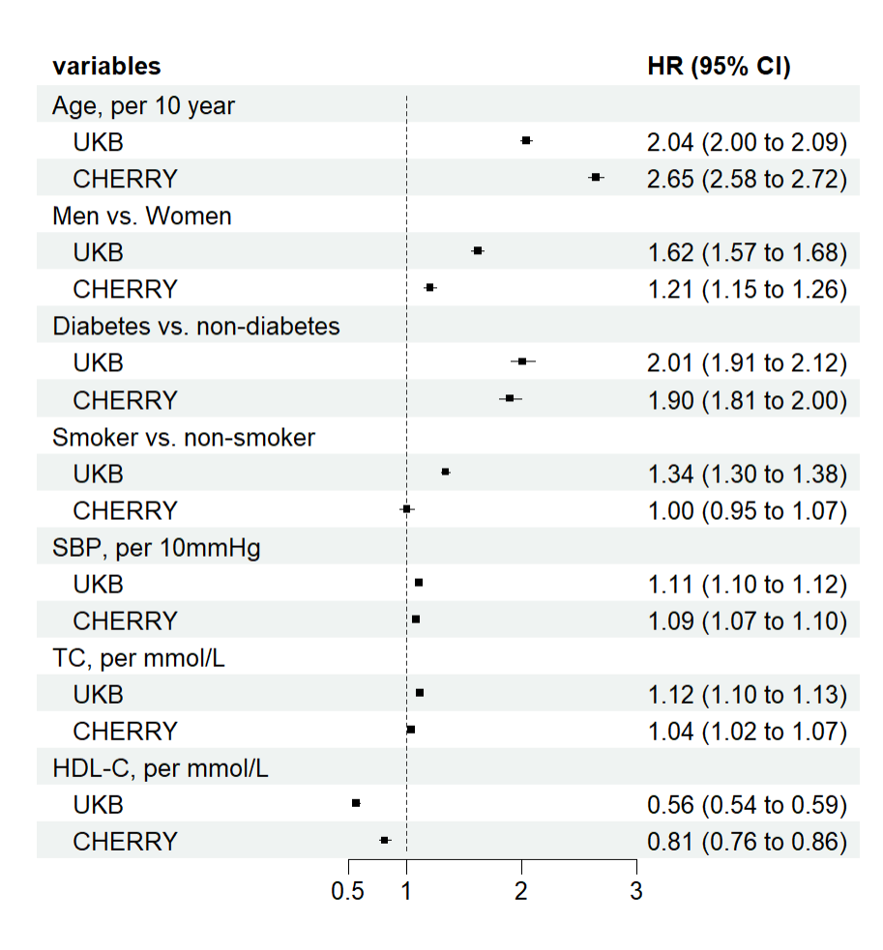
Hazard ratios (HRs) were estimated using Cox regression, adjusted for age at baseline, sex, smoking status, history of diabetes, SBP, TC and HDL-C levels.

Supplementary Figure 2. Calibration plot for 10-year risk in the UK Biobank internal validation set.
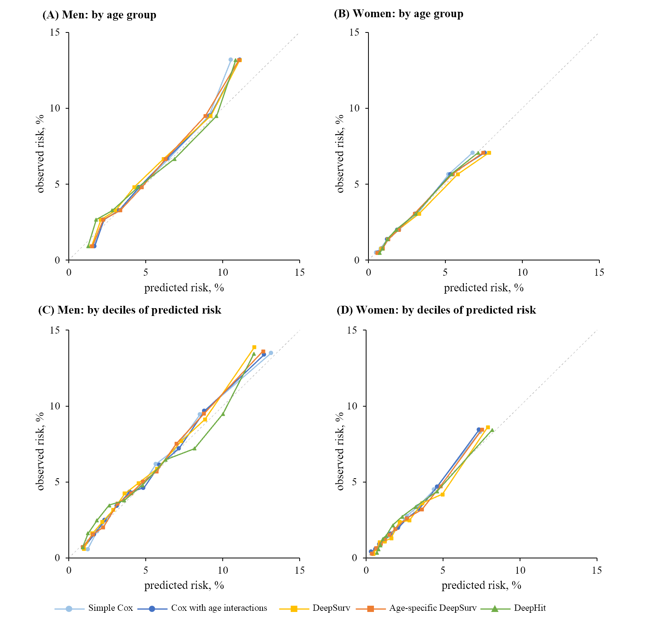

Supplementary Figure 3. Smoothed calibration curve by risk group in the CHERRY validation set.
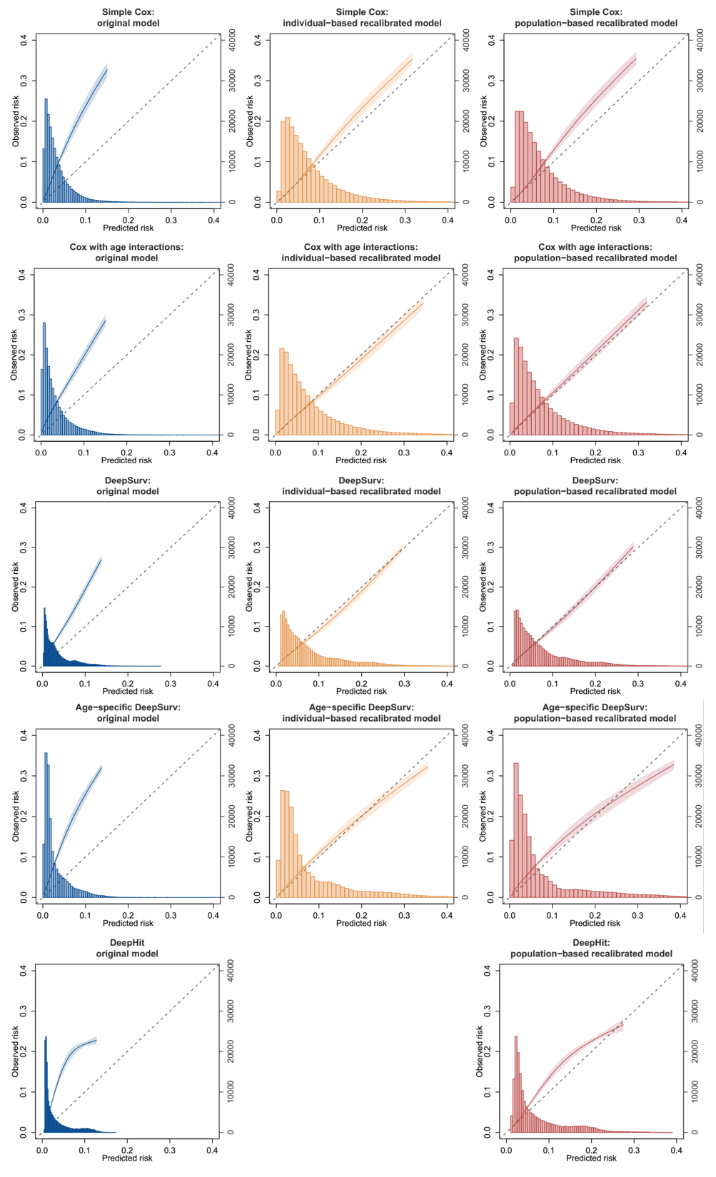

Supplementary Figure 4. 10-year risk distribution of original and recalibrated SNN models in the CHERRY.
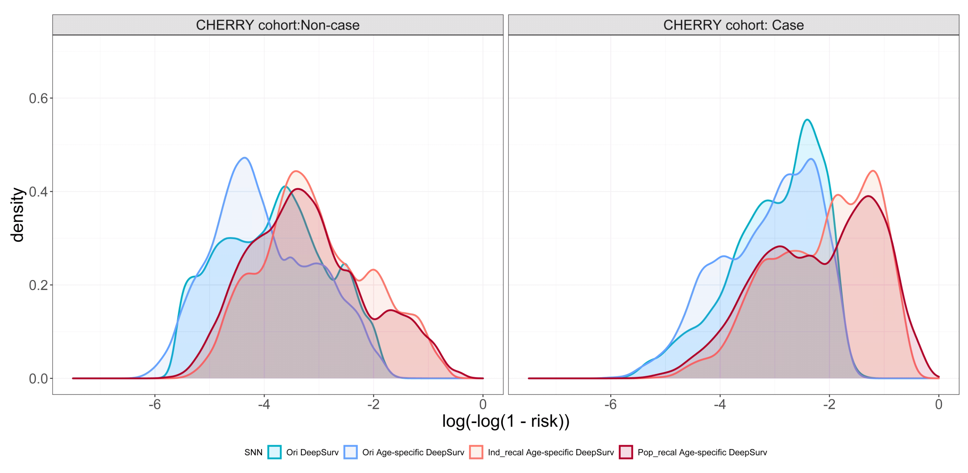
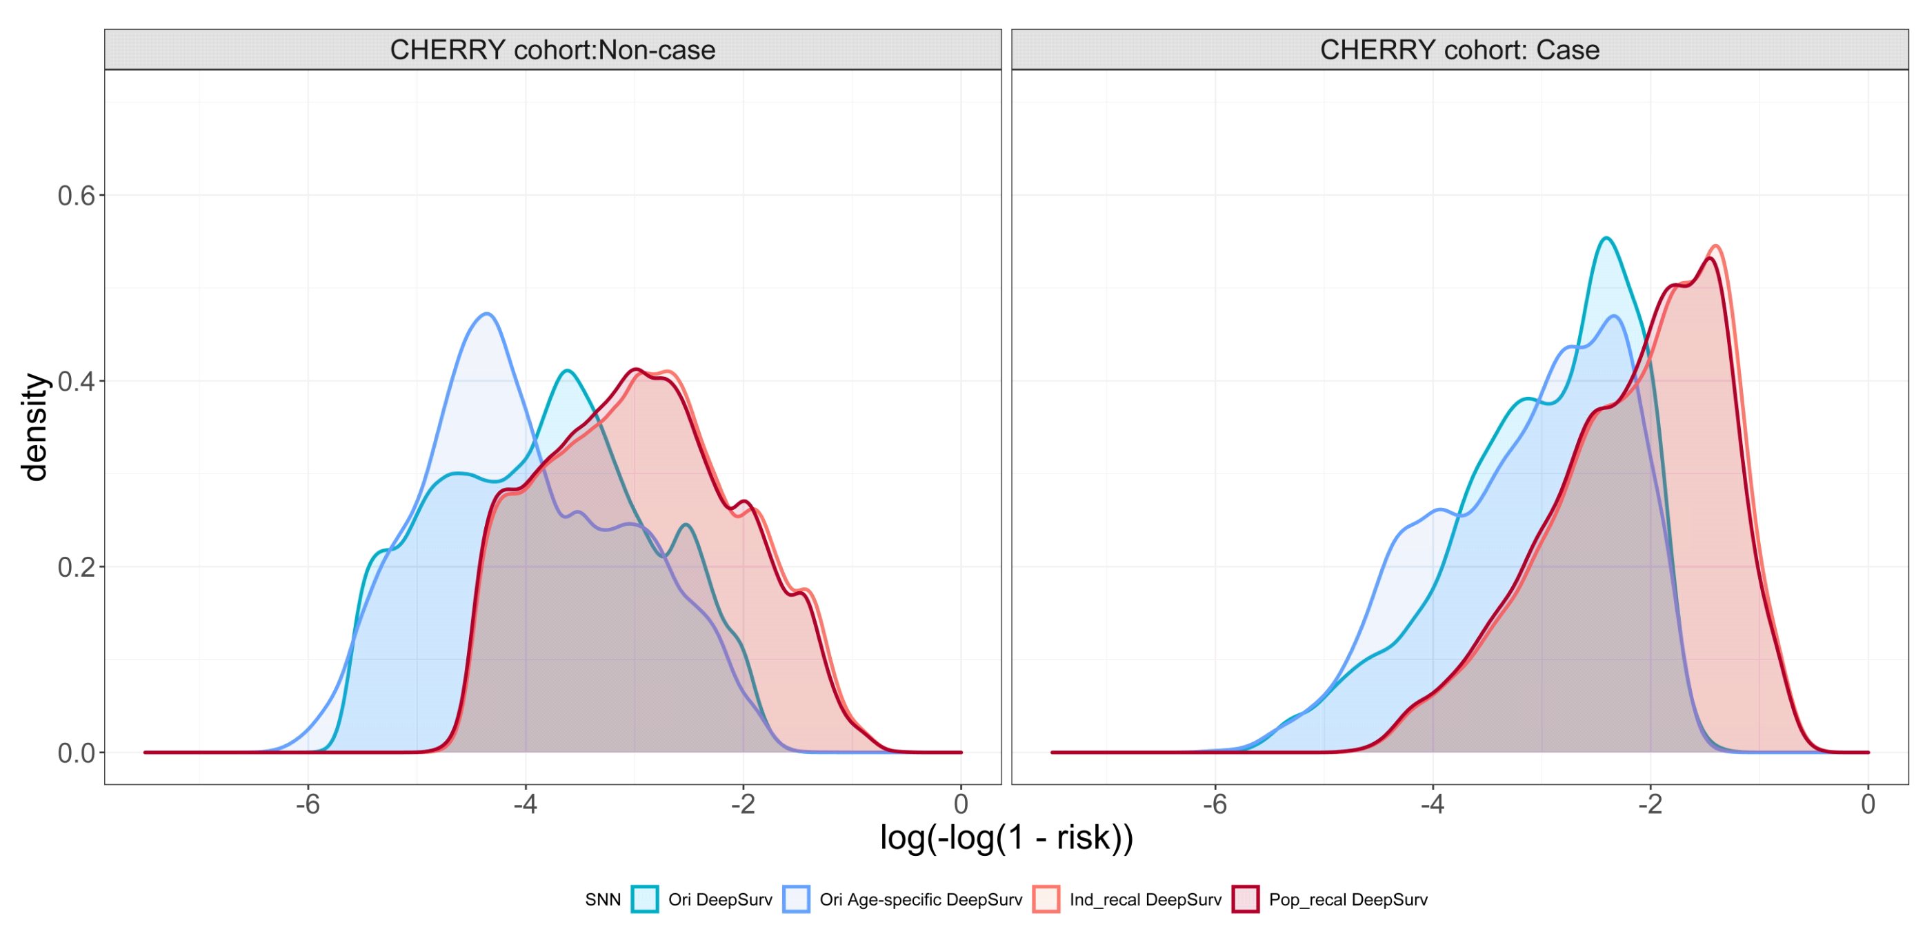

Supplementary Figure 5. Calibration plot by age group for 10-year CVD risk in the CHERRY external validation set.
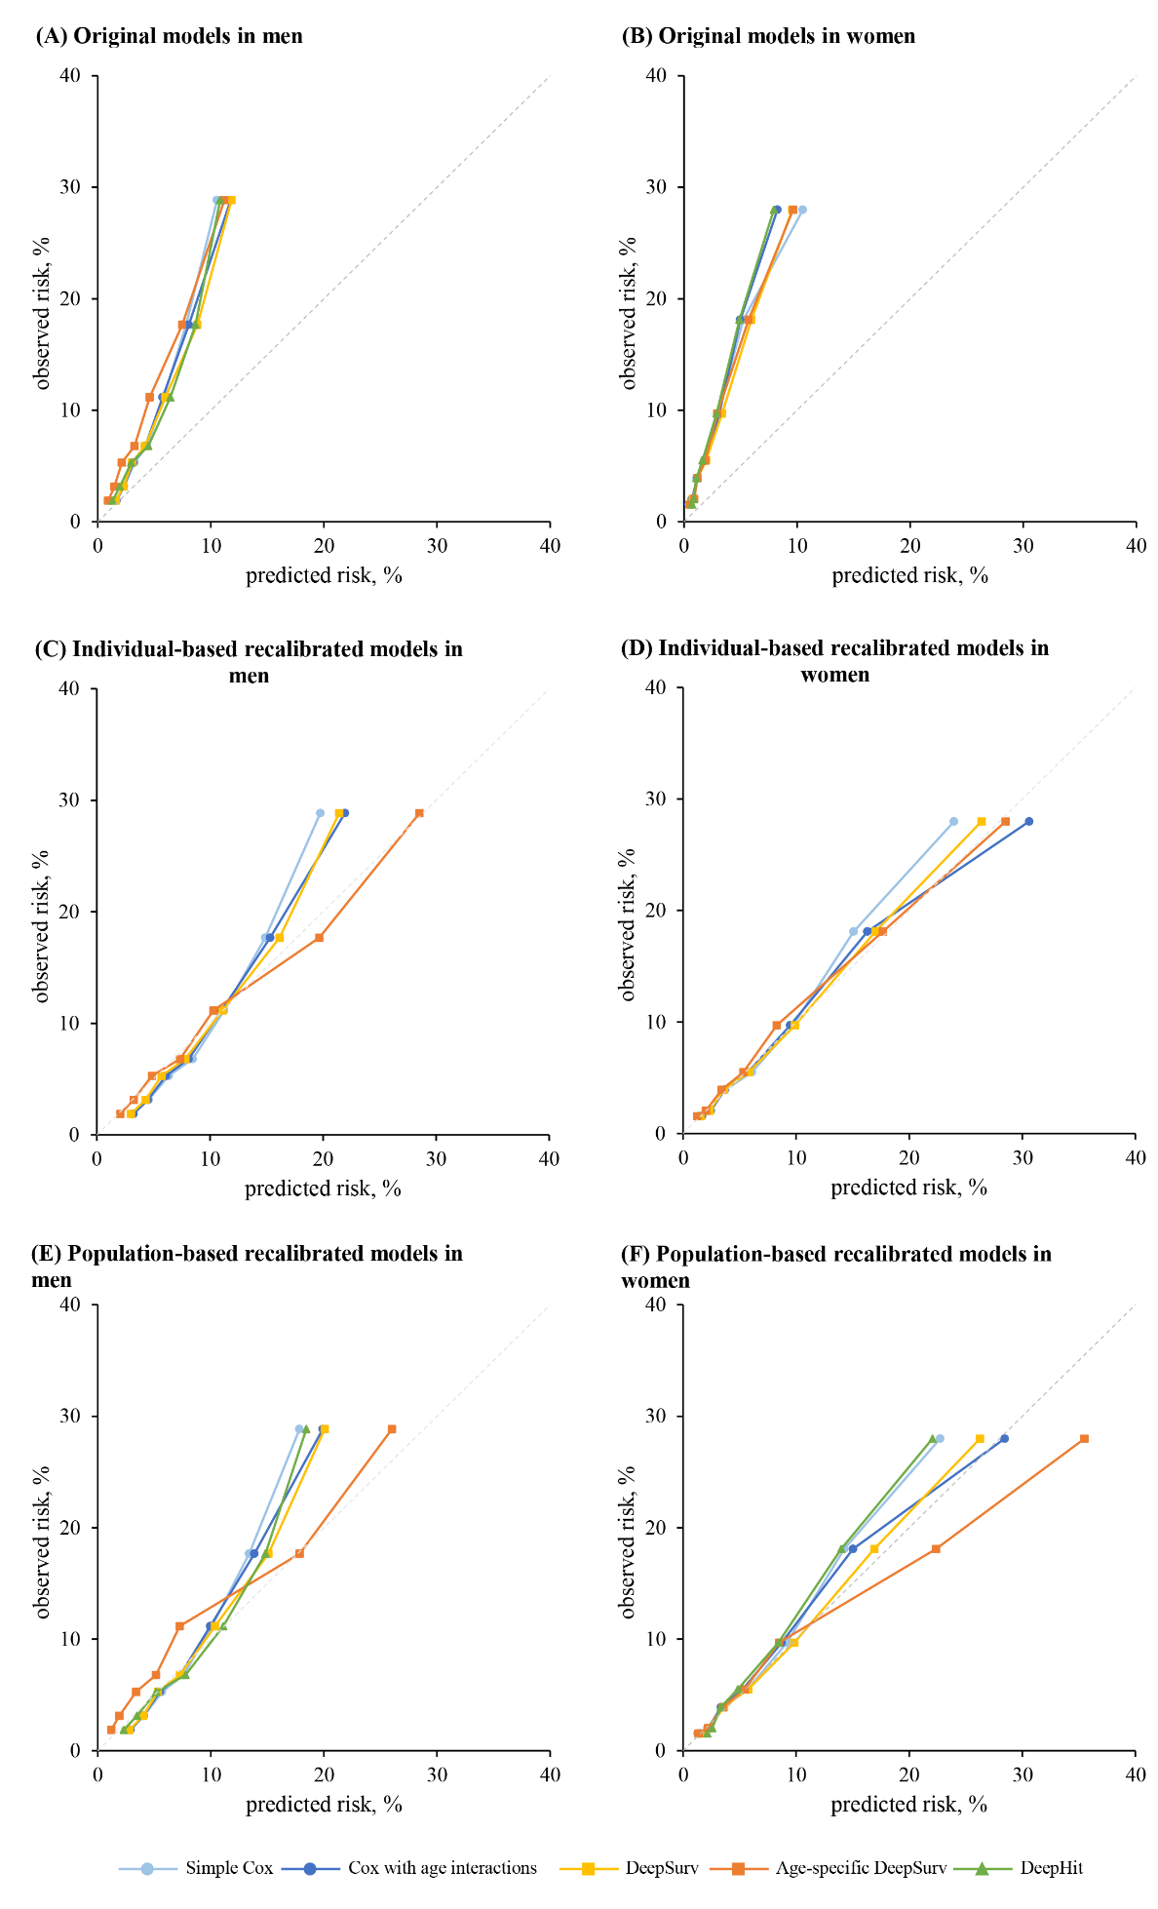

Supplementary Figure 6. 10-year risk distribution of original Cox and SNN models in the UKB and CHERRY.
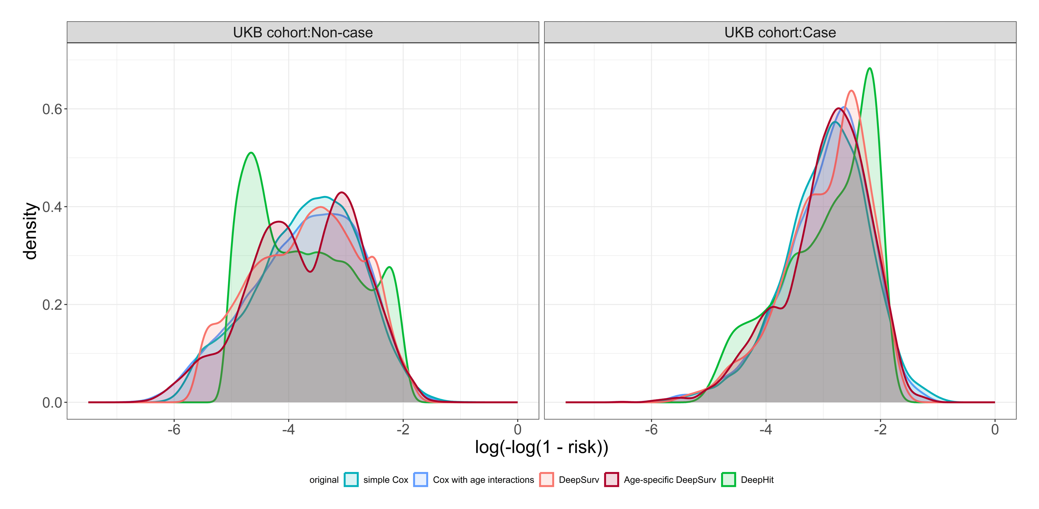
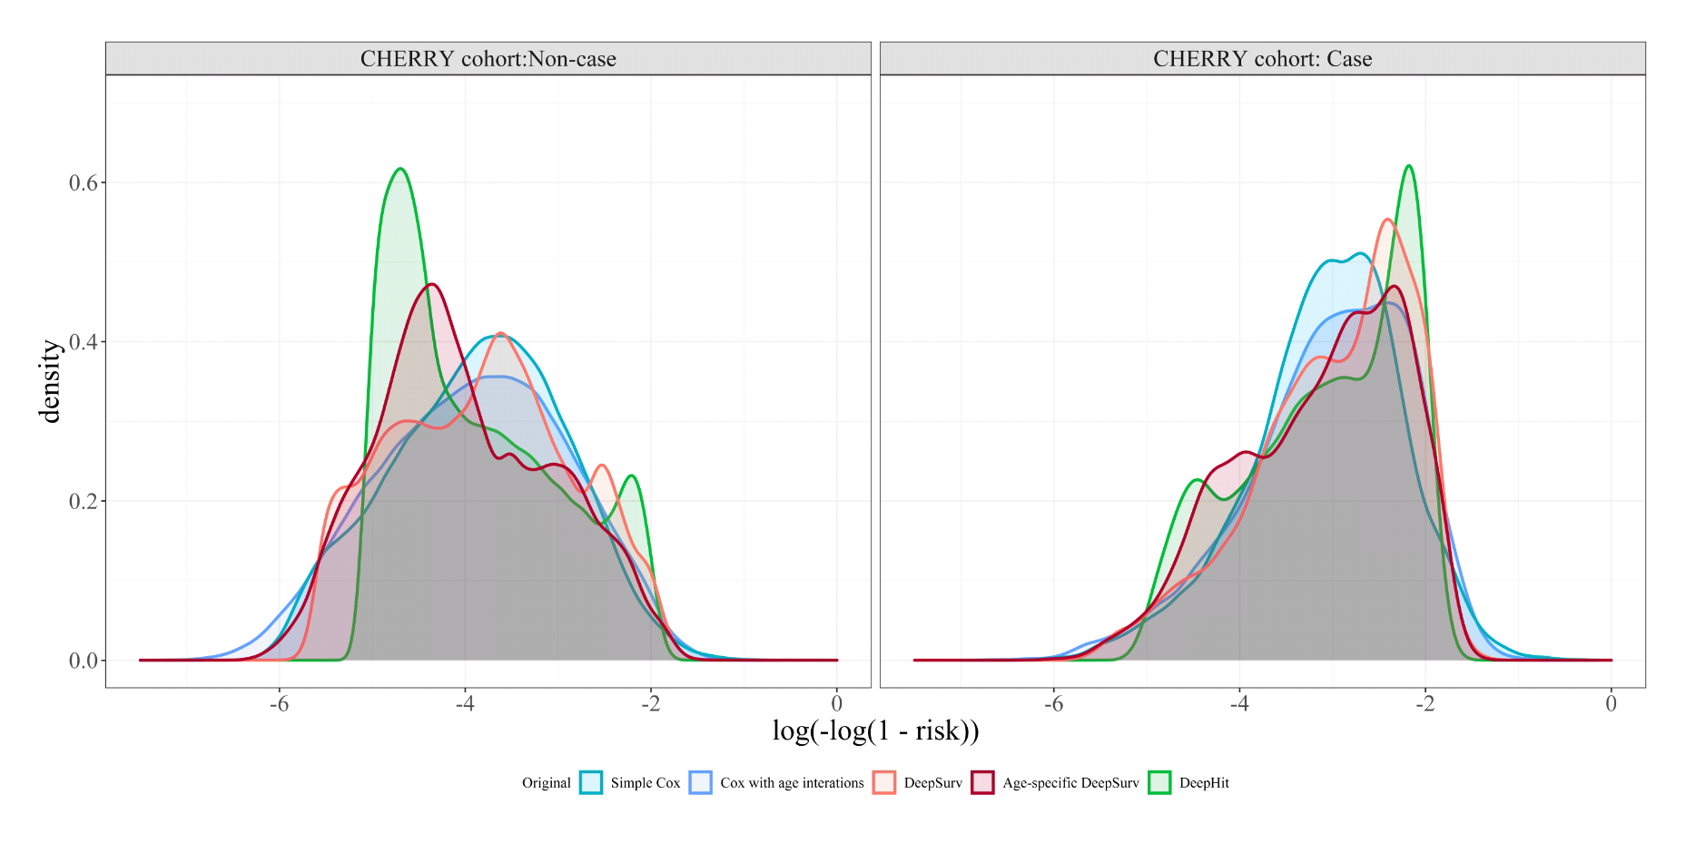

TRIPOD-AI Checklist
Section/Topic | Item | Development/evaluation | Checklist item | Reported on page
TITLE
Title | 1 | D;E | Identify the study as developing or evaluating the performance of a multivariable prediction model, the target population, and the outcome to be predicted | Title Page
ABSTRACT
Abstract | 2 | D;E | See TRIPOD+AI for Abstracts checklist | Abstract Page
INTRODUCTION
Background | 3a | D;E | Explain the healthcare context (including whether diagnostic or prognostic) and rationale for developing or evaluating the prediction model, including references to existing models | 1.Introduction
 | 3b | D;E | Describe the target population and the intended purpose of the prediction model in the context of the care pathway, including its intended users (e.g., healthcare professionals, patients, public) | 1.Introduction
 | 3c | D;E | Describe any known health inequalities between sociodemographic groups | 1.Introduction
Objectives | 4 | D;E | Specify the study objectives, including whether the study describes the development or validation of a prediction model (or both) | 1.Introduction
METHODS
Data | 5a | D;E | Describe the sources of data separately for the development and evaluation datasets (e.g., randomised trial, cohort, routine care or registry data), the rationale for using these data, and representativeness of the data | 2.1 study population
 | 5b | D;E | Specify the dates of the collected participant data, including start and end of participant accrual; and, if applicable, end of follow-up | 2.1 study population
Participants | 6a | D;E | Specify key elements of the study setting (e.g., primary care, secondary care, general population) including the number and location of centres | 2.1 study population
 | 6b | D;E | Describe the eligibility criteria for study participants | 2.1 study population
 | 6c | D;E | Give details of any treatments received, and how they were handled during model development or evaluation, if relevant | Not applicable
Data preparation | 7 | D;E | Describe any data pre-processing and quality checking, including whether this was similar across relevant sociodemographic groups | 2.1 study population
Outcome | 8a | D;E | Clearly define the outcome that is being predicted and the time horizon, including how and when assessed, the rationale for choosing this outcome, and whether the method of outcome assessment is consistent across sociodemographic groups | 2.2 outcome definition
 | 8b | D;E | If outcome assessment requires subjective interpretation, describe the qualifications and demographic characteristics of the outcome assessors | Not applicable
 | 8c | D;E | Report any actions to blind assessment of the outcome to be predicted | NA
Predictors | 9a | D | Describe the choice of initial predictors (e.g., literature, previous models, all available predictors) and any pre-selection of predictors before model building | 2.1 study population
 | 9b | D;E | Clearly define all predictors, including how and when they were measured (and any actions to blind assessment of predictors for the outcome and other predictors) | Supplementary Table 1
 | 9c | D;E | If predictor measurement requires subjective interpretation, describe the qualifications and demographic characteristics of the predictor assessors | Not applicable
Sample Size | 10 | D;E | Explain how the study size was arrived at (separately for development and evaluation), and justify that the study size was sufficient to answer the research question. Include details of any sample size calculation | Figure 1, Supplementary Methods
Missing data | 11 | D;E | Describe how missing data were handled. Provide reasons for omitting any data | 4. discussion
Analytical methods | 12a | D | Describe how the data were used (e.g., for development and evaluation of model performance) in the analysis, including whether the data were partitioned, considering any sample size requirements | 2.5 model evaluation
 | 12b | D | Depending on the type of model, describe how predictors were handled in the analyses (functional form, rescaling, transformation, or any standardisation). | Supplementary Table 2-3
 | 12c | D | Specify the type of model, rationale², all model-building steps, including any hyperparameter tuning, and method for internal validation | 2.3 risk prediction models; Supplementary Table 2-3
 | 12d | D;E | Describe if and how any heterogeneity in estimates of model parameter values and model performance was handled and quantified across clusters (e.g., hospitals, countries). See TRIPOD-Cluster for additional considerations³ | Not applicable
 | 12e | D;E | Specify all measures and plots used (and their rationale) to evaluate model performance (e.g., discrimination, calibration, clinical utility) and, if relevant, to compare multiple models | 2.5 model evaluation
 | 12f | E | Describe any model updating (e.g., recalibration) arising from the model evaluation, either overall or for particular sociodemographic groups or settings | 2.4 model recalibration; Figure 2; Supplementary Method, Supplementary Table 4
 | 12g | E | For model evaluation, describe how the model predictions were calculated (e.g., formula, code, object, application programming interface) | 2.3 risk prediction models
Class imbalance | 13 | D;E | If class imbalance methods were used, state why and how this was done, and any subsequent methods to recalibrate the model or the model predictions | Not applicable
Fairness | 14 | D;E | Describe any approaches that were used to address model fairness and their rationale | NA
Model output | 15 | D | Specify the output of the prediction model (e.g., probabilities, classification). Provide details and rationale for any classification and how the thresholds were identified | 2.4 model recalibration; 2.5 model evaluation
Training versus evaluation | 16 | D;E | Identify any differences between the development and evaluation data in healthcare setting, eligibility criteria, outcome, and predictors | Table 1, Supplementary Table 5
Ethical approval | 17 | D;E | Name the institutional research board or ethics committee that approved the study and describe the participant-informed consent or the ethics committee waiver of informed consent | Acknowledgments
OPEN SCIENCE
Funding | 18a | D;E | Give the source of funding and the role of the funders for the present study | Acknowledgments
Conflicts of interest | 18b | D;E | Declare any conflicts of interest and financial disclosures for all authors | Declaration of competing interest
Protocol | 18c | D;E | Indicate where the study protocol can be accessed or state that a protocol was not prepared | Not applicable
Registration | 18d | D;E | Provide registration information for the study, including register name and registration number, or state that the study was not registered | Not applicable
Data sharing | 18e | D;E | Provide details of the availability of the study data | Data sharing statement
Code sharing | 18f | D;E | Provide details of the availability of the analytical code | Data sharing statement
PATIENT & PUBLIC INVOLVEMENT
Patient & Public Involvement | 19 | D;E | Provide details of any patient and public involvement during the design, conduct, reporting, interpretation, or dissemination of the study or state no involvement. | Acknowledgments
RESULTS
Participants | 20a | D;E | Describe the flow of participants through the study, including the number of participants with and without the outcome and, if applicable, a summary of the follow-up time. A diagram may be helpful. | 3.1 Population characteristics; Figure1
 | 20b | D;E | Report the characteristics overall and, where applicable, for each data source or setting, including the key dates, key predictors (including demographics), treatments received, sample size, number of outcome events, follow-up time, and amount of missing data. A table may be helpful. Report any differences across key demographic groups. | 3.1 Population characteristics, Table 1
 | 20c | E | For model evaluation, show a comparison with the development data of the distribution of important predictors (demographics, predictors, and outcome). | 3.1 Population characteristics, Table 1
Model development | 21 | D;E | Specify the number of participants and outcome events in each analysis (e.g., for model development, hyperparameter tuning, model evaluation) | 3.1 Population characteristics; Table 1, Supplementary Table 2-3
Model specification | 22 | D | Provide details of the full prediction model (e.g., formula, code, object, application programming interface) to allow predictions in new individuals and to enable third-party evaluation and implementation, including any restrictions to access or re-use (e.g., freely available, proprietary) | Supplementary Table 2-3, Data sharing statement
Model performance | 23a | D;E | Report model performance estimates with confidence intervals, including for any key subgroups (e.g., sociodemographic). Consider plots to aid presentation. | 3.2-3.4, Table2, Supplementary Table 6-14, Figure 3-4, Supplementary Figure 2-7
 | 23b | D;E | If examined, report results of any heterogeneity in model performance across clusters. See TRIPOD Cluster for additional details³. | Not applicable
Model updating | 24 | E | Report the results from any model updating, including the updated model and subsequent performance | 3.2-3.4, Table2, Supplementary Table 6-14, Figure 3-4, Supplementary Figure 2-7
DISCUSSION
Interpretation | 25 | D;E | Give an overall interpretation of the main results, including issues of fairness in the context of the objectives and previous studies | 4. discussion
Limitations | 26 | D;E | Discuss any limitations of the study (such as a non-representative sample, sample size, overfitting, missing data) and their effects on any biases, statistical uncertainty, and generalizability | 4. discussion
Usability of the model in the context of current care | 27a | D | Describe how poor quality or unavailable input data (e.g., predictor values) should be assessed and handled when implementing the prediction model | 4. discussion
 | 27b | D | Specify whether users will be required to interact in the handling of the input data or use of the model, and what level of expertise is required of users | 4. discussion
 | 27c | D;E | Discuss any next steps for future research, with a specific view to applicability and generalizability of the model | 4. discussion
TRIPOD, Transparent Reporting of a Multivariable Prediction Model for Individual Prognosis or Diagnosis.

